Power Modules

Abstract
This document summarizes the power modules in the market that fit the design specifications, which are categorized by following manufacturer:
- Powerrex
- International Rectifier
- Fairchild
- Vishay
- FUJI
- Infineon
- Semikron
The datasheet can be viewed by clicking the corresponding headings.
A discussion has been made in the end comparing the power modules.

Design Specifications
Parameter | Ratings
Input Voltage | 220
I_{C} (A) | 8 ~ 35 (at all temperatures)
Switching Frequency (kHz) | 20 ~ 30
Switching Time (us) | 33 ~50
Application Power rating (kW) | 1 ~ 30
Configurations | Full bridge
Switching Devices | IGBTs, GTO, FETs
Output frequency (Hz) | 1 ~ 500

1. Powerrex
1.1 PM25CL1B120 Three Phase IGBT Inverter
- Complete Output Power Circuit
- Gate Drive Circuit
- Low-loss, Full Gate CSTBT IGBTs (6th Generation IGBT)

Parameter | Ratings
V_{CES} (V) | 1200
I_{C} (A) 25º | 25 (peak 50)
I_{C} (A) 100º | N/A
Switching Frequency (kHz) | 20
Configurations | Full bridge
Switching Devices | IGBTs (CSTBT)
Price (USD) | 157.72*

Same series: PM800HSA060 (800A, 60V), PM75RL1A060 (75A, 60V), PM75CLB120 (75A, 120V) etc. around 20 models in this series.

1.2 PS22A78-E Dual-in-Line Intelligent Power Module
Features
- Low-loss, Full Gate CSTBT IGBTs (6th Generation IGBT)
- Single Power Supply
- Integrated HVICs
- Direct Connection to CPU

Parameter | Ratings
V_{CES} (V) | 1200
I_{C} (A) 25º | 35 (peak 70)
I_{C} (A) 100º | N/A
Switching Frequency (kHz) | 20
Configurations | Full bridge
Switching Devices | IGBTs (CSTBT)
Price (USD) | 96.00*

Same series: PS22A74 (15A)

1.3 PS22054 Dual-in-Line Intelligent Power Module
Features
- Low-loss, Full Gate CSTBT IGBTs (6th Generation IGBT)
- Single Power Supply
- Integrated HVICs
- Direct Connection to CPU
- Compact Packages

Parameter | Ratings
V_{CES} (V) | 1200
I_{C} (A) 25º | 15 (peak 30)
I_{C} (A) 100º | N/A
Switching Frequency (kHz) | 20
Configurations | Full bridge
Switching Devices | IGBTs (CSTBT)
Price (USD) | 72.00*

Same series: CM100RX-24S (1200V, 100A)

1.4 PM25CL1B120 Three Phase IGBT Inverter
Powerex Intellimod™ Intelligent Power Modules are isolated base modules designed for power switching applications operating at frequencies to 20kHz. Built-in control circuits provide optimum gate drive and protection for the IGBT and free-wheel diode power devices.

Parameter | Ratings
V_{CES} (V) | 1200
I_{C} (A) 25º | 25 (peak 50)
I_{C} (A) 100º | N/A
Switching Frequency (kHz) | up to 20
Supply Voltage (V) | 20
Configurations | Full bridge
Switching Devices | IGBTs
Price (USD) | 157.72*

2. International Rectifier
IRAMX16UP60B Integrated Power Hybrid IC
Features
- Integrated Gate Drivers
- Temperature Monitor
- Non Punch through IGBT

Parameter | Ratings
V_{CES} (V) | 600
I_{C} (A) 25º | 16
I_{C} (A) 100º | 8
Switching Frequency (kHz) | up to 20
Application Power (kW) | 0.75 ~ 2.2
Supply Voltage (V) | 12 ~ 20
Configurations | Full bridge
Switching Devices | IGBTs
Price (USD) | 34.38

Same series: IRAMX16UP60A

3. Fairchild
Fairchild power modules have built-in gate controllers
3.1 FSAM20SH60A Smart Power Module
V_{CES} (V) | 600
I_{C} (A) 25º | 30
I_{C} (A) 100º | 16
Switching Frequency (kHz) | 15 (optimized)
Application Power (kW) | 1.5
Supply Voltage (V) | 450
Configurations | Full bridge
Switching Devices | IGBTs
Price (USD) | 24.97

3.2 FSBB15CH60C
V_{CES} (V) | 600
I_{C} (A) 25º | 15
I_{C} (A) 100º | -
Switching Frequency (kHz) | 20
Application Power (kW) | 1.5
Supply Voltage (V) | 450
Configurations | Full bridge
Switching Devices | IGBTs
Price (USD) | 18.54

Same Series: FSBB30CH60 (30A)

4. Vishay
CPV364M4FPbF IGBT SIP Module
Parameter | Ratings
V_{CES} (V) | 600
I_{C} (A) 25º | 27
I_{C} (A) 100º | 15
Switching Frequency (kHz) | 10 (optimized)
Application Power (kW) | 4 (at 10kHz)
Supply Voltage (V) | 360Vdc
Configurations | Full bridge
Switching Devices | IGBTs
Price (USD) | 76.86

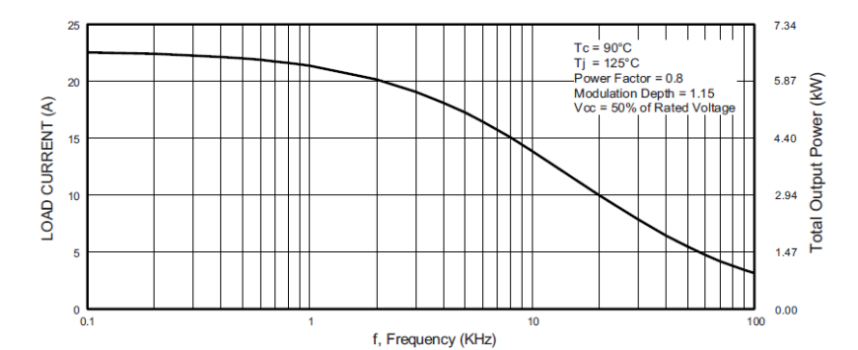

Same Series: CPV364M4KPbF (low I_{c} when ambient temperature is high)

5. FUJI
7MBR25SA-120 IGBT Module
Parameter | Ratings
V_{CES} (V) | 1200/1600
I_{C} (A) 25º | 35
I_{C} (A) 80º | 25
Turn on + off time (us) | 0.8 << 33
Application Power (kW) | For aircons etc.
Supply Voltage (V) | 360Vdc
Configurations | Full bridge
Switching Devices | IGBTs
Price (USD) | 127.54

Same series: 7MBR35SB140 (1400V, 32A)

6. Infineon
FP15R12W1T4
Parameter | Ratings
V_{CES} (V) | 1200
I_{C} (A) 25º | 28
I_{C} (A) 100º | 15
Turn on + off time (us) | 0.28 << 33
Application Power (kW) | For aircons etc.
Supply Voltage (V) | -
Configurations | Full bridge
Switching Devices | IGBTs
Price (USD) | 127.54

Same series: FS75R12W2T4, FS20R06W1E3, FP15R12W1T4_B3

7. Semikron
SKiM429GD17E4HD
Parameter | Ratings
V_{CES} (V) | 1700
I_{C} (A) 25º | 595
I_{C} (A) 70º | 479
Turn on + off time (us) | 10 << 33
Application Power (kW) | AC inverter drives
Supply Voltage (V) | -
Configurations | Full bridge
Switching Devices | IGBTs (Trench)
Price (USD) | 117.40

Same series: SKiM459GD12E4 (1200V, 554A); SKIM609GAL12E4 (1200V, 748A); SKiM909GD066HD (600V, 899A); SKIM609GAR12E4 (1200V, 748A)

8. Discussion
The mainstream switching devices of power modules are IGBTs. There are limited numbers of power modules using power FETs and GTOs. However, they do not meet our design requirement. Comparing these three models, the second one is deemed to be the best fit and it is relatively cheap.

